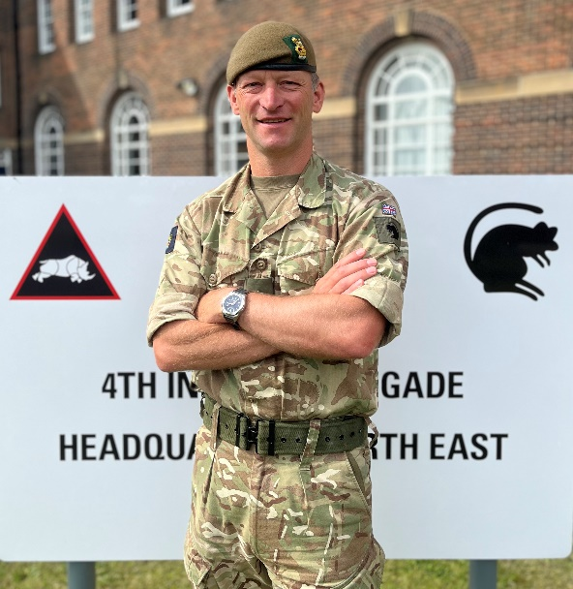

Colonel Matt Palmer

Commander Headquarters South West

Colonel Matt Palmer commissioned into the 1st Battalion The Duke of Wellington’s Regiment (West Riding) in 1998. He platoon commanded on Public Duties in Hounslow prior to a spell as an instructor at the Infantry Training Centre (Catterick). He re-joined the 1st Battalion in Osnabruck as an armoured infantry company 2ic before becoming the adjutant. The Battalion deployed to Kosovo and Iraq (Op TELIC 1) from Germany.

On the staff he has been SO2 Armed Forces’ Pay Review Body in the Ministry of Defence, Directing Staff at the Intermediate Command and Staff Course (Land), SO2 Infantry at the Command and Staff Trainer (Germany) and, briefly, a company commander at the Royal Military Academy Sandhurst. At OF4 he has been SO1 Command Doctrine in the Land Warfare Centre, SO1 of the Junior Staff Centre, an advisor at the Kabul Military Training Centre and SO1 of the Combat Ready Training Centre.

In command he was officer commanding of an armoured infantry company in the 3rd Battalion The Yorkshire Regiment in Warminster. This included a BATUS deployment, a tour as the PROFOR Company in Baghdad (Op TELIC 14) and a Falkland Island Roulement Infantry Company rotation. At unit level, he had the privilege of commanding 1 Army Training Regiment (Pirbright). Deputy Commander 4 Brigade.

He assumed the role of Commander Headquarters South West in Jan 24. He is married to Beth, has two young sons and enjoys rugby, surfing, fly fishing and skiing.

