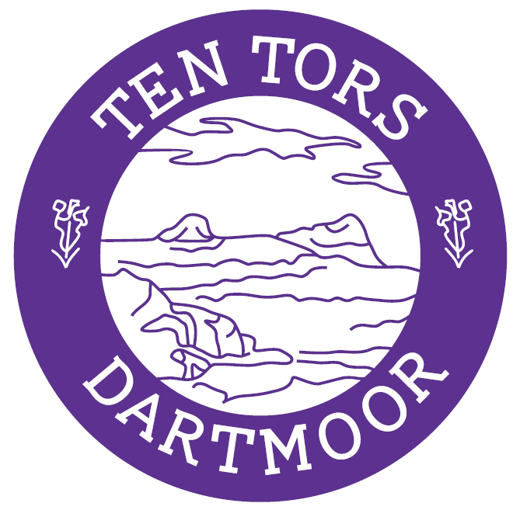

TEN TORS 2018
TEAM MANAGERS INFORMATION SHEET

INTRODUCTION

1. Welcome to Okehampton Training Camp and Exercise WYVERN TOR 2018 (WT18). The administration for the exercise and camp area is being conducted by 6th Battalion The Rifles.

2. Our aim is to make your stay as enjoyable as possible but please bear in mind that there will be 3500 participants and helpers on the campsites, 1000 military personnel in the Camp and upwards of 5000 supporters visiting.

RESPONSIBILITIES

3. The Defence Infrastructure Organisation and 6 RIFLES will endeavour to make the Camp and campsites as safe as reasonably practicable. You are reminded of the need to observe all Safety, Health and Environmental Protection rules. Please treat the Camp with care and have due consideration for the safety and health of others as well as yourselves.

4. Team Managers are responsible for their participants, helpers and visitors, and must brief them within 30 minutes of arrival on a campsite. Supporters will receive basic safety, health and environmental information in the Ten Tors Brochure issued to all drivers on arrival in the car parks.

SAFETY, HEALTH AND ENVIRONMENTAL PROTECTION

5. Generators. To enable emergency announcements to be heard, in consideration of others, and to reduce fuel hazards, generators are not permitted on the campsites.

6. Fire Precautions. Please help to reduce the risk of fire by not smoking in tents, by cooking carefully, by having appropriate fire extinguishers to hand, and by minimising the quantity of gas and fuel on the campsites - All visitors who intend to use gas canisters in the campsites must ensure that they observe a 6-metre safety distance from accommodation tents (this includes camper vans located on the parking area). Keep the fire exit routes clear and make sure that everyone knows where they are.

7. Action on the outbreak of fire. Raise the alarm by shouting FIRE, FIRE, FIRE, call 01837 657186 and 999 and muster on the Parade Square. Team Managers are to report missing persons to a Steward.

8. Camp Site Layout. Please keep your tents close together with walkways leading to the fire exit routes. Liaise with your neighbours to ensure walkways are joined up. Observe the 6m separation space between cooking areas and other tents.

9. Medical Assistance. The British Red Cross First Aid post is to the south of the Parade Square.

10. Waste. This year, with the assistance of our contractor, we will once again be green with regard to waste. There will be general waste and recycling bins placed throughout the Camp and campsites, please use the correct bins.

11. Litter. Please pick up litter and dispose of it correctly. Every little helps.

12. Dogs. Dogs may only transit through the camp and on Sunday through the campsites. Please clear up behind your dog and place the waste in the non-recyclable waste skips.

13. Alcohol. Team staff, especially minibus drivers who might be needed to support Contingency Plans, are encouraged not to drink alcohol.

14. Safeguarding. Team Managers are responsible for the conduct and safeguarding of any of their Establishment participants and minors, and for the behaviour of their team staff and supporters on the campsite.

VEHICLES

15. You are to follow the one-way circuit and comply with the speed limit in Camp of 15 mph. Drivers must obey the directions of Traffic Marshals and Stewards, who are identifiable by high viz waistcoats.

16. No vehicle is allowed on the campsites except essential vehicles with organiser’s authority and Jubilee Challenge essential medical vehicles with Exeter UOTC permission.

17. Please ensure you park your vehicle in the public car park. Your vehicle will be towed away or you may receive a fixed penalty notice from the Police if it is parked illegally or causing an obstruction.

18. Vehicles may be unloaded on the Parade Square, on the road alongside campsites Y and Z, or from the areas within the car park close to the gates to the west of campsites A –F and JC.

19. Camp Exit. There will be NO vehicle exit from Okehampton Training Camp on Sat 12 May between 0600-0700 hrs. On Sun 13 May between 0900 and 1700 you will be directed onto the slip road onto the A30 westbound to reduce congestion in Okehampton - Slip off at the next junction if you wish to drive in the Exeter direction.

TRIBAR FACILITIES

20. There is a TRIBAR facility at Okehampton Camp, which is located in Building 112. Opening times for the TRIBAR during Ten Tors 2018 are as follows:

a. Fri 11 May 18 0900-1200 & 1700 – 2300hrs

b. Sat 12 May 18 0800 – 2300hrs

c. Sun 13 May 18 0800 - 2300hrs

BAND PERFORMANCE

21. The Band of The Adjutant General’s Corps will be performing at the times and locations listed below.

a. Fri 11 May 2000-2100 TriBar

b. Sat 12 May 1100-1500 JC Finish

c. Sat 12 May 2000-2200 TriBar (2 x 45 min sets)

d. Sun 13 May 1000-1400 TTC Finish

WHAT TO DO IF YOU HAVE A PROBLEM
22. Public Information is available in Building 83 East, the Hangar, marked  on the Camp map between 0600 and 2100 hours Saturday and 0700 until Ten Tors is complete on Sunday.
If you have any problems or issues concerning administration during your stay, please direct them to QM 6 RIFLES, Major Steve Tisbury or WO2 Dave Thomas who will be located in Building 130 marked on the Okehampton Camp Plan.

CONTACT NUMBERS

23. The contact numbers for the QM & RQMS 6 RIFLES, who will deal with ALL Exercise Wyvern Tor 2018 administration matters, are:

a. QM Major Steven Tisbury W: 94363 3264 M: 07411 408191
C: 01837 657263

b. RQMS (WO2) Darren Thomas W: 94363 3264 M: 07440 290246
C: 01837 657263

24. This information contained above is designed to help with the smooth running of the Camp and campsites to help make your stay as enjoyable as possible - please follow the direction given. We do hope you have an enjoyable stay.

S Tisbury

Major

QM 6 RIFLES



